Web development

Assignment no1

Name Rafay shabbir(21i0619)

Task1:

<!DOCTYPE html>

<html lang="en">

<head>

    <meta charset="UTF-8">

    <meta name="viewport" content="width=device-width, initial-scale=1.0">

    <title>Landing Page</title>

    <style>

        body {

            margin: 0;

            padding: 0;

            font-family: Arial, sans-serif;

        }

        nav {

            background-color: #333;

            color: #fff;

            padding: 15px 20px;

            display: flex;

            justify-content: space-between;

            align-items: center;

        }

        nav a {

            color: #fff;

            text-decoration: none;

            margin: 0 10px;

            transition: color 0.3s ease;

        }

        nav a:hover {

            color: #ffd700;

        }

        nav a:visited {

            color: #fff;

        }

        nav a.active {

            font-weight: bold;

        }

        .hero {

            background-image: url('lp.jpg');

            background-size: cover;

            background-position: center;

            height: 500px;

            display: flex;

            justify-content: center;

            align-items: center;

            color: #fff;

            text-align: center;

        }

        .hero-text {

            padding: 20px;

        }

        footer {

            background-color: #333;

            color: #fff;

            padding: 20px 0;

            text-align: center;

        }

        footer p {

            margin: 0;

        }

    </style>

</head>

<body>

    <nav>

        <div class="logo">

            <img src="logo.jpg" alt="Logo" width="50">

        </div>

        <div class="nav-links">

            <a href="https://www.nu.edu.pk/Home" class="active">Home</a>

            <a href="https://murreebrewery.com/history/">About</a>

            <a href="https://murreebrewery.com/category/murrees-beers/">Services</a>

            <a href="https://murreebrewery.com/contact/">Contact</a>

        </div>

    </nav>

    <div class="hero">

        <div class="hero-text">

            <h1> Welcome to Our Website</h1>

            <p>We provide you the best services in town</p>

        </div>

    </div>

    <footer>

        <p>© 2024 Rafay Limited All Rights Reserved.</p>

</body>

</html>

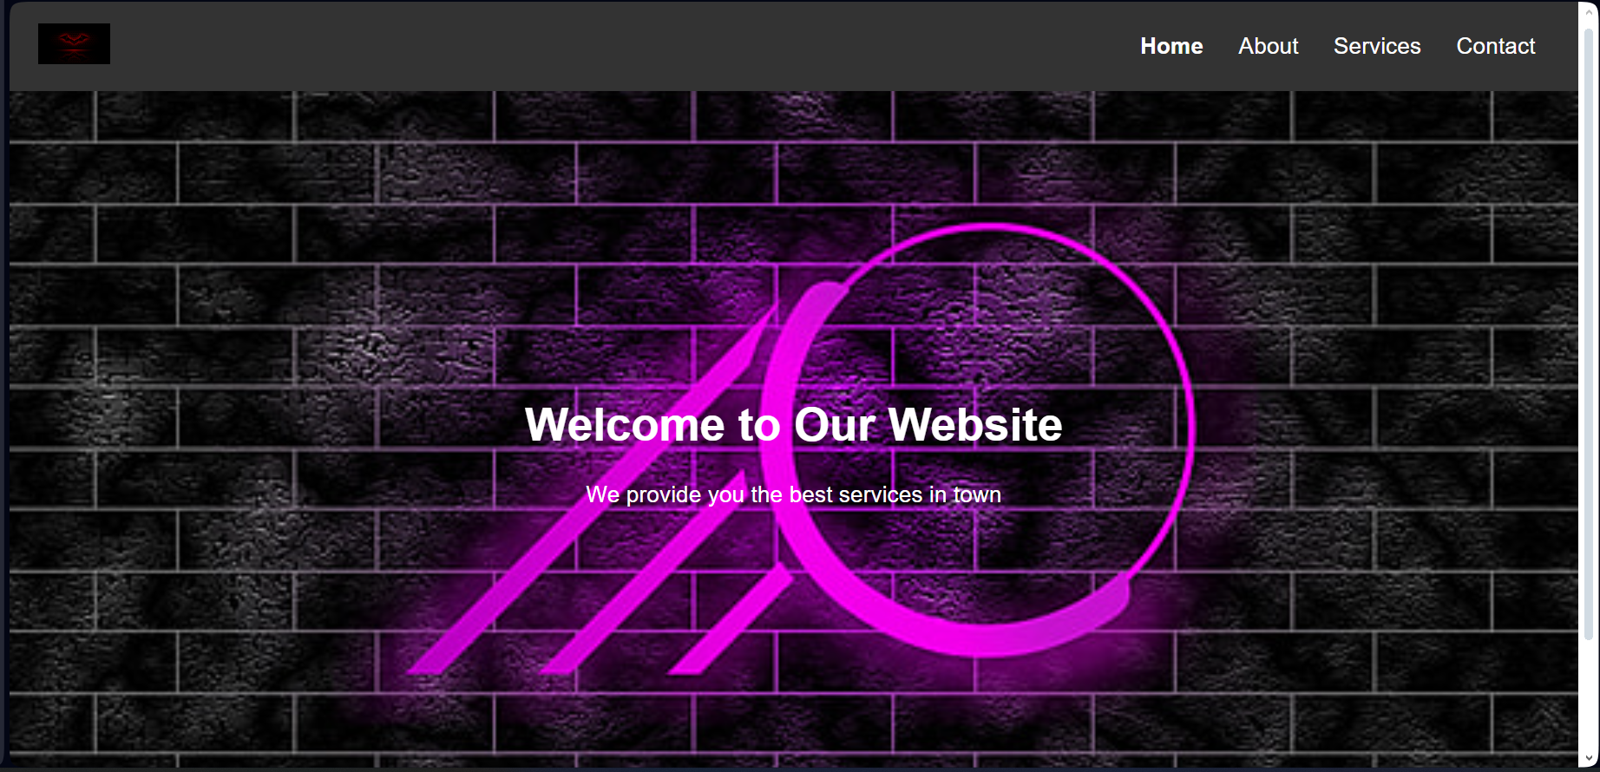

Task2:

Html

<!DOCTYPE html>

<html lang="en">

<head>

    <meta charset="UTF-8">

    <meta name="viewport" content="width=device-width, initial-scale=1.0">

    <title>Sign-In and Sign-Up Page</title>

    <link rel="stylesheet" href="style.css">

</head>

<body>

    <div class="image">

        <div class="formbox">

            <div class="button">

                <div id="butn"></div>

                <input type="radio" name="form-switch" id="login" class="toggle" checked>

                <label for="login" class="toggle-button">Log-In</label>

                <input type="radio" name="form-switch" id="register" class="toggle">

                <label for="register" class="toggle-button">Register</label>

            </div>

            <form id="login-form" class="input">

                <input type="text" class="input-field" placeholder="User Id" required>

                <input type="password" class="input-field" placeholder="Enter Password" required>

                <input type="checkbox" class="check-box"><span>Remember Password</span>

                <button type="submit" class="submitbutton">Log In</button>

            </form>

            <form id="register-form" class="input" style="display: none;">

                <input type="text" class="input-field" placeholder="User Id" required>

                <input type="password" class="input-field" placeholder="Enter Password" required>

                <input type="email" class="input-field" placeholder="Enter Email-Id" required>

                <input type="checkbox" class="check-box"><span>I Agree to terms and Conditions</span>

                <button type="submit" class="submitbutton">Register</button>

            </form>

        </div>

    </div>

    <script>

        document.getElementById("register").addEventListener("click", **function** () {

            document.getElementById("login-form").style.display = "none";

            document.getElementById("register-form").style.display = "block";

        });

        document.getElementById("login").addEventListener("click", **function** () {

            document.getElementById("register-form").style.display = "none";

            document.getElementById("login-form").style.display = "block";

        });

    </script>

</body>

</html>

Css code

* {

    margin: 0;

    padding: 0;

    font-family: sans-serif;

}

.image {

    height: 100vh;

    background-image: linear-gradient(rgba(0, 0, 0, 0.4), rgba(0, 0, 0, 0.4)), url(demo.jpg);

    background-position: center;

    background-size: cover;

    display: flex;

    justify-content: center;

    align-items: center;

}

.formbox {

    width: 380px;

    height: auto;

    background: linear-gradient(to right, #ff105f, #ffad06);

    padding: 20px;

    border-radius: 10px;

}

.button {

    display: flex;

    justify-content: center;

    margin-bottom: 20px;

}

.toggle {

    display: none;

}

.toggle-button {

    padding: 10px 20px;

    cursor: pointer;

    background: transparent;

    border: none;

    outline: none;

    position: relative;

    font-size: 18px;

    color: #fff;

    transition: 0.3s;

}

.toggle-button:hover {

    background: rgba(255, 255, 255, 0.2);

    border-radius: 5px;

}

.input {

    display: none;

}

.input-field {

    width: 100%;

    padding: 10px;

    margin-bottom: 10px;

    border: none;

    border-radius: 5px;

}

.check-box {

    margin-right: 5px;

}

.submitbutton {

    width: 100%;

    padding: 10px;

    border: none;

    border-radius: 5px;

    background: linear-gradient(to right, #ff105f, #ffad06);

    color: #fff;

    cursor: pointer;

}

.submitbutton:hover {

    background: linear-gradient(to right, #ff105f, #ffad06);

    opacity: 0.8;

}

